Modeling of coupling coefficient as a function
of coupling ratio

¹SAKTIOTO,²JALIL ALI, ³MOHAMMED FADHALI,
²ROSLY ABDUL RAHMAN, ²JASMAN ZAINAL

¹Physics Dept, Math and Science Faculty, University of Riau
Pekanbaru, Tel.+62 761 63273, Indonesia, email: saktioto@yahoo.com
²Institute of Advanced Photonics Sciences
Science Faculty, Universiti Teknologi Malaysia (UTM)
81310 Skudai, Johor Bahru, Malaysia, Tel.07-5534110, Fax 07-5566162
³Physics Dept, Faculty of Science, Ibb University, Yemen

Abstract

Coupled 1X2 Single Mode Fiber (SMF-28e®) has been successfully fabricated using a slightly unstable torch flame at a temperature range of 800ºC to 1350ºC injecting hydrogen gas flowing at pressure of 1 bar. The coupling ratio and coupling coefficient can be examined from 1% until 75%. In this paper, we compare the experimental results by using a simple kinetic model of coupling coefficient where internal and external parametric functions are considered. This equation is time independent and is then integrated over the coupling ratio range for various separation fibers axis between two cores. The result shows that the separation between the cores significantly affects coupling coefficient exhibiting exponential behavior. In this experiment the coupling coefficient gradient is significantly changed towards the coupling ratio but in modeling it has a function of separation fiber axis and no power imposed. These phenomena will determine the effects of power losses at coupling region where fabrications of coupled fibers are demonstrated.

Keywords: single mode fiber, coupling coefficient, power

- INTRODUCTION

Over the past two decades, single-mode fibers (SMF) coupler has been one of the most important fiber optic devices in telecommunications. Various applications have been demonstrated and made that utilized fiber coupling as junctions to combine and to split optical signals for optical switches, tunable filters and modulators ^{[1-3]}. There are many kinds of ways to couple fibers. It is not surprising that 1X2 SMF-28e® coupled fibers have been successfully fabricated by a slightly unstable torch flame in the range of 800ºC-1350ºC by injecting hydrogen gas at a pressure of 1 bar as shown in Figure 1. Two fibers are twisted once to have a tightly coupling when the fibers are pulled by a vacuum pump in the range of 7500-9500μm with a velocity ≈100μm/s ^{[4]}. A 1mW power with a laser diode source wavelength 1310nm propagates the wave along fiber 1 and at coupling region some of them are split to fiber 2 and then the dividing power is recorded by a photo detector. This operation produces the coupling ratio in the range of 1% to 75%.

Laser Diode, 1mW,
1310nm
Fiber Optic
Photo Detector
Monitor

H₂ gas
Vacuum Pump

Torch

Figure [1]. The schematic of SMF-28e® coupler process [4]

The fiber coupling fabrication has resulted in good coupling ratio (CR) and coupling coefficient for both transmission and coupling power ^{[5,6]}. However, the effect of heating, the geometry and structure of fibers coupling may change and produce lower refractive indices than the previous one. Therefore when the claddings and cores at a fiber coupling region are surrounded by a medium with refractive index lower than that of claddings such as air or gel, the wave propagation to core and cladding may radiate due to perturbation of fibers. These will produce various kinds of losses when the wave reaches fibers coupling region that are coated with a material of refractive index equal or higher than claddings, resulting in power losses occurring at the coupling region.

In order to determine the power propagation over coupling ratio at the junctions of fibers, it is important to examine accurate coupling coefficient and separation of fiber axis between cores. Because core radius and normalized frequency are responsible for coupling coefficient ^{[7,8]}, we should be more careful when making any approximation when calculating coupling coefficient ^{[9,10]}. The calculation of the coupling coefficient for coupled fibers is also very complicated, especially when the core and cladding refractive index are nearly the same. Therefore, in order to calculate these parameters under various conditions theoretically, a simple kinetic model has been developed. The modeling is approached through an empirical calculation of time independent and dimensional dependent. This model can be used to compare it with experimental results and treat them by imposing several CR and separation of fiber axis between two cores. The modeling can also provide inputs to spectroscopic investigation of coupled fibers and applications to microstructure optical fiber ^{[11,12]}.

2. KINETIC MODEL OF FIBER COUPLING COEFFICIENT

To describe the fiber coupling coefficient as a function of coupling ratio, the kinetic model is proposed using the continuity equation with parametric vectors written as:

$\frac{∂\vec{κ}}{∂t}+∇\text{.}(v\vec{κ})=\vec{S}$ (1)

where κ is coupling coefficient, ν velocity, t time, and S is the source. Since κ is time independent and ν is constant then
$$∇\text{.}\vec{κ}=\vec{S}$$

The notation of $∇$is operated along a function of a coupling ratio (CR) then $∇≡\text{CR}$, or

$$\frac{∂\vec{κ}}{∂(\text{CR})}=\vec{S}$$

The external parametric function of the source S is the temperature (T) involved in heating the fibers, whereas the internal parametric function is the source wavelength (λ) and power (P). κ_{o} represents the coupling coefficient due to geometrical effects of fibers. Therefore S can be expressed as

$$\vec{S}=\frac{∂\vec{κ_{o}}}{∂(\text{CR})}+f^{'}(\vec{λ},\vec{P})+f^{'}(\vec{T})$$

with f’ is the first order derivation of CR. Then the equation becomes,

$\frac{∂\vec{κ}}{∂(\text{CR})}=\frac{∂\vec{κ_{o}}}{∂(\text{CR})}+f^{'}(\vec{λ},\vec{P})+f^{'}(\vec{T})$ (2)

In order to obtain a complete solution, each terms of Equation (2) are evaluated thoroughly.

Coupling ratio in terms of a fraction power splitting at fiber junction is defined as ^{[13]},

$$\text{CR}(\text{\%})=\frac{P_{b}(z)}{P_{a}(z)+P_{b}(z)}$$

where P_{a} and P_{b} are transmission and coupling power respectively. If the source power, P_{o} has no losses as it propagate along the fiber length and also at the junctions, then P_{o}= P_{a}(z) + P_{b}(z) . However, power propagation at coupling region is affected by geometrical and structural behavior of the fibers. Taking this into account, the coupling ratio for fraction power of P_{b} can then be defined as follows ^{[14]},

$\text{CR}|_{P_{b}}=\frac{κ^{2}}{κ^{2}+δ^{2}}{\text{sin}}^{2}[(κ^{2}+δ^{2})^{1/2}z]x\text{100}\text{\%}$ (3)

Here δ is the phase mismatch factor defined as (β₁- β₂)/2, where β₁ and β₂ representing phase constant of fiber 1 and 2. Assuming δ=0, then the phase velocities in the two modes are equal such that a complete power transfer occurred over the coupling length, z=L_{c}, or L_{c}=π/(2κ). If δ≠0 then the maximum fraction of power is $\frac{κ^{2}}{κ^{2}+δ^{2}}$. A simple empirical relationship is then used to calculate the coupling coefficient where ^{[13]}:

κ = (π/2) (√δ/a) exp [- (A + B đ + c đ ²)] (4)
where
A = 5.2789 – 3.663V + 0.3841V²
B = -7769 + 1.2252V – 0.012V²
C = -0.0175 – 0.0064V – 0.0009V²
δ = (n₁²-n₂²)/n₁² ; and,
đ = d/a

The initial values of core and cladding refractive index are, n_{co}=1.4677 and n_{cl}=1.4624 respectively, where a is the core radius of fiber, and d is the separation between two fiber cores. For SMF-28e® with the core and cladding diameter of 8.2μm and 125μm respectively, the dominant mode is LP₀₁, with a normalized frequency, V = (2πa/λ) (n₁² – n₂²)^{1/2} ^{[15,16]} is equal to 2.405.

Using Equations (3) and (4), Equation (2) can be evaluated. The first term in Equation (2) is then obtained by,

$$\frac{∂\vec{κ_{o}}}{∂(\text{CR})}=$$
$+\frac{π}{2a}\text{exp}[−(A+B\overline{d}+C{\overline{d}}^{2})]\vec{\frac{∂}{∂(\text{CR})}}(\sqrt{δ})$ (5)

For simplicity, Equation (5) can be divided into three separated terms,

$\frac{∂\vec{κ_{o}}}{∂(\text{CR})}=\vec{κ_{o1}}+\vec{κ_{o2}}+\vec{κ_{o3}}$ (6)

where,

$\vec{κ_{o1}}=\frac{π}{2a}\sqrt{δ}\text{exp}(−(A+B\overline{d}+C{\overline{d}}^{2}))$
$+[(1\text{.}\text{2252}−2(0\text{.}\text{0152}))\overline{d}\frac{\vec{∂V}}{∂(\text{CR})}]+[(−0\text{.}\text{0064}−2(0\text{.}\text{0009}V)){\overline{d}}^{2}\frac{\vec{∂V}}{∂(\text{CR})}]$
$$\vec{κ_{o2}}=$$
$\vec{κ_{o3}}=\left\{\frac{π}{2a}\text{exp}[−(A+B\overline{d}+C{\overline{d}}^{2})][(1−\frac{n_{2}^{2}}{n_{1}^{2}})(\frac{n_{2}}{n_{1}}\frac{\vec{{∂n}_{2}}}{∂(\text{CR})}+\frac{n_{2}^{2}}{n_{1}^{3}}\frac{\vec{∂n_{1}}}{∂(\text{CR})})]\right\}$

The second term in Equation (2) shows the power (P) and source wavelength (λ) are also affected by the geometry and structure of coupled fibers. Since they are constant at input and output port then the total power does not change except partially along coupling region. Unless the propagation constant remains, the wavelength will be affected. Hence,

$f^{'}(\vec{λ},\vec{P})=[(\frac{∂\vec{κ}}{∂λ})(\frac{\vec{∂λ}}{∂(\text{CR})})]+[(\frac{∂\vec{κ}}{∂P})(\frac{\vec{∂P}}{∂(\text{CR})})]$ (7)

Consider the case where the power and wavelength have no dependence on each other when perturbed by heating of fibers and no changes towards coupling ratio range. This means that derivations only depend on coupling coefficient.

Experimentally, the temperature imposed to the fiber coupling is not constant, but depends on position. Assuming that at the highest temperature position the coupling ratio can be achieved even in a slightly unstable torch flame. The third term of Equation (2), T can be expressed as,

$f^{'}(\vec{T})=[(\frac{∂\vec{κ}}{∂T})(\frac{\vec{∂T}}{∂(\text{CR})})]$ (8)

Both coupling coefficient and temperature vary over source flame and coupling ratio respectively. A higher coupling coefficient is obtained when the heating duration is longer. However, since the timer controls the preset of coupling ratio at the earliest and optimal condition, then the coupling coefficient can be independent of time. This means that the coupling coefficient is experimentally controlled by coupling ratio itself rather than source flame. The second part of the derivation shows that the temperature is not constant. This is experimentally true as the torch flame flow produces temperature variations with respect to position of fiber in all cases. Fiber surfaces are not only heated at the center of coupling region or coupling length but also in the range of coupling region. Therefore, this term can be determined from experimental results.

Combining Equation (6), (7) and (8) and substitute into Equation (2), we have

(I) (II)

$\frac{∂\vec{κ}}{∂(\text{CR})}=(\vec{κ_{o1}}+\vec{κ_{o2}}+\vec{κ_{o3}})+$$[(\frac{∂\vec{κ}}{∂λ})(\frac{\vec{∂λ}}{∂(\text{CR})})]+[(\frac{∂\vec{κ}}{∂P})(\frac{\vec{∂P}}{∂(\text{CR})})]$
(III)

$+[(\frac{∂\vec{κ}}{∂T})(\frac{\vec{∂T}}{∂(\text{CR})})]$ (9)

Again, when vectors are used to describe the separations of fiber axis (d) as a row vectors, then the distribution of the d along coupling ratio can be visualized.

3. INTEGRATION AND COMPARISON OF COUPLING COEFFICIENT

Experimentally, coupling coefficient implicitly depends upon time, however since the coupling ratio is also actually the coupling power then the coupling coefficient is affected by fiber dimension and is purely controlled by coupling ratio. Figure 2 depicts the coupling length which requires wider distance when the coupling ratio increases. However; theoretically it is not expected for the coupling length to be wider as long as the coupling power has been coupled and reached to the pre-set value of coupling ratio resulting in linearly trend lines. It is affected by the time and pulling of fibers during fusion. In fact, the coupling ratio can be reached with no coupling length dependence or has a constant value. Again, this occurs due to the effect of fabrication in order to obtain certain coupling length, refractive index changes and mainly separation of fiber axis of two cores for the shortest time to achieve. The range of coupling length has the distance possibility of the two cores so that the power can travel to another fiber within a much shorter time as compared with a constant coupling range.

Figure [2]. Coupling length to reach coupling ratio,[4]

Figure [3]. Coupling coefficient after fusion, [4]

In Figure 3, the coupling coefficient is also nearly linear in the range of 0.55-0.85/mm and the trend lines gradient is 0.0024. The curve describes various values of d shown by the dot decreased with the increase of the coupling ratio. However, d variations are not very clear. A complete coupling coefficient has been achieved while the minimum d to obtain splitting power during fusion cannot be detected. Therefore, to determine a minimum d for each coupling ratio, we find the radial and axial part of fiber change is almost comparable, then d gradient is nearly proportional to coupling length gradient with 0.0134. Both figures however cannot reach a complete range of 100% coupling ratio since the fibers are heated with a slightly unstable torch flame. A higher coupling coefficient indicates that more power can be split to another fiber. The coupling coefficient increases over the coupling ratio in order to reach the nearest separation fiber axis between the cores. Although the coupling coefficient does not affect the coupling ratio but it does depends on the distance between two cores. Therefore in both figures coupling length and coupling coefficient are not implicitly affected by coupling ratio provided that the two fibers are pulled and heated.

The simulation result of kinetic model is shown in Figure 4. It is found that the coupling coefficient for four differences of separation fiber axis of two cores increases from 0.024 until 0.054 over the coupling ratio 0-100%. The positive gradient is due to the increasing of coupling length and the separation fiber axis between two cores along coupling ratio. Comparing it to experimental result, the gradient difference is by a factor 10. This means that experimentally, fiber coupling is very much affected by pulling and heating while theoretically it has no source power being imposed to obtain the coupling coefficient as described by Equation (4).

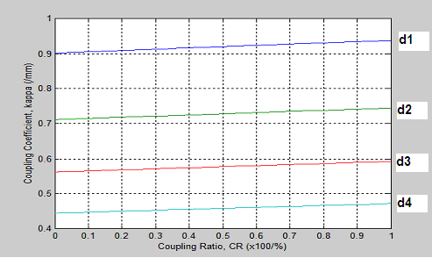

Figure [4]. Coupling coefficient with d₁=9.5x10⁻⁶; d₂ =10x10⁻⁶; d₃ =10.5x10⁻⁶; d₄ =11x10⁻⁶m
(dV/dr =0.5 ; da/dr =1044.3864x10⁻⁶ ; dn₂/dr = 2.05x10⁻⁶; dn₁ /dr =1.05x10⁻⁶) ^{[17]}

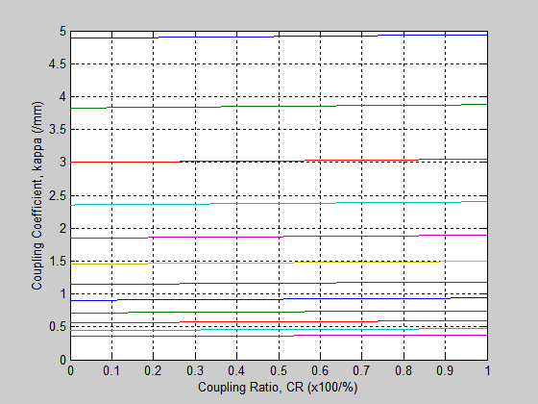

Figure 5. Coupling coefficient for several separation fiber axis (d).
In Figure 5, the separation difference of two cores d in a row vector shown from highest to lowest coupling coefficient is set respectively as follows:

d=[6.5 ; 7 ; 7.5 ; 8 ; 8.5 ; 9 ; 9.5 ; 10 ; 10.5 ; 11 ; 11.5 ; 12] x10⁻⁶m.

In Figure 5, the twelfth value of d is expected as the highest possible distance between two cores. This vector describes how the distances of the two cores move closer and perpendicular to propagation direction of wave as the coupling ratio increases. Simulation results indicate that the higher the coupling coefficient, the smaller the separation between cores. Additionally, the coupling coefficient increases exponentially more towards another vertical than in horizontal direction. If the coupling coefficient is increased significantly, then integration over the coupling ratio results in a large gradient range of the coupling coefficient.

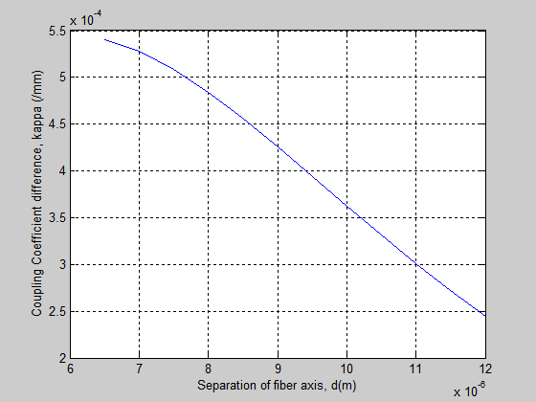

Figure 6. Coupling coefficient difference for CR=1-100%

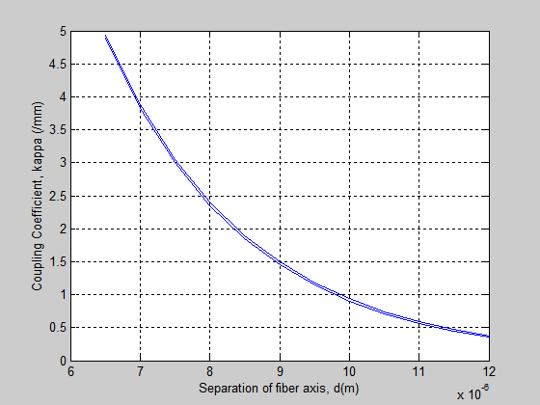

Figure 7. Coupling coefficient changes for CR=1-100%

Figure 6 depicts the coupling coefficient integration difference from the final point to initial point. Calculation was carried out using the Runge Kutta method in the range of CR for each separation of fiber axis vector. These show that coupling coefficient decreases 10⁻²/CR or by factor 10⁻⁴ and nearly linear for separation of fiber axis which is greater than 7.8x10⁻⁶m. Below this value, it will be slightly exponential. The power tends to move significantly and rapidly due to the effect of refractive index surrounding the two cores, which is actually associated with two claddings. Figure 7 shows the coupling coefficient as a function of separation of fiber axis. The two curves almost superimposed each other as a result of the small difference between final and initial integration of coupling coefficient.

From Equation 9, it is found that the change of κ_{o1} in term I is very significant. This means that it contributes to coupling coefficient by factor 10⁻² in the range of 0.0539-0.00245, while for κ_{o2} and κ_{o3} by factor 10⁻¹⁸ and 10⁻⁴ respectively. The κ is much more affected by exponential factor of [- (A + B đ + c đ ²)] where it implicitly explains that the normalized frequency gradient is the dominant factor compared to the derivation of both δ and a. On the other hand, term II and term III are weak disturbances in terms of coupling coefficient.

The terms II and III are very small and are absorbed in the functions of κ_{o1} and κ_{o3}. The inequality $(\frac{∂κ}{∂λ})\text{>>}(\frac{∂λ}{∂(\text{CR})})$ and $(\frac{∂κ}{∂P})>(\frac{∂P}{∂(\text{CR})})$ describes the gradient results of two equations on the left hand side which is higher than that of the wavelength and power gradient. The wavelength and partial power over the coupling ratio is of the order 10⁻⁹ and 10⁻³ respectively and are much less compared to both sides on the left of the derivatives. Within the coupling coefficient range of 10⁻³ both the derivative equations leads to the first equation which is 10⁶ times higher than the second equation. Quantitatively, the value of $(\frac{∂κ}{∂λ})$ is not affected by coupling ratio portion. On the other hand, it is affected by $(\frac{∂κ}{∂P})$ which is of the order of 1. The temperature derivatives obtained is $(\frac{∂κ}{∂T})<(\frac{∂T}{∂(\text{CR})})$. The left and right hand side are different by the order of 10⁻³ and 10² respectively. Multiplying each part of term II and III will produce the order 10⁻¹ per thousands of coupling coefficient. This shows that the two perturbation parts contribute to coupling coefficient over coupling ratio effectively at the coupling region.

4. CONCLUSION

A simple kinetic model is used to calculate the coupling coefficient over the range of coupling ratio 1-100% has been developed. It is found to be in good agreement with the experimental results. The model shows that the coupling coefficient has a slightly higher change over coupling ratio than that of experimental result where separation between cores varies by a difference of 0.0106. This discrepancy is due to the power and coupling length imposed by the coupling ratio for a constant separation fiber between two cores, while in the model, power and temperature have an insignificant influence. However, both coupling coefficient does not affect the overall performance of the SMF28e® coupler.

ACKNOWLEDGMENT

We would like to thank the Government of Malaysia, Universiti Teknologi Malaysia (UTM), Islamic Development Bank (IDB) and University of Riau, Indonesia in supporting this research.

REFERENCES

[1] J. M. Senior, Optical Fiber Communications, Principles and Practice. 2nd edition, Prentice Hall of India, New Delhi,1996.
[2] I. Yokohama, J. Noda and K Okamoto, “Fiber-Coupler Fabrication with Automatic Fusion-Elongation Processes for Low Excess Loss and High Coupling-Ratio Accuracy”, J.Lightwave Technology, 5(7), 910-915, (1987).
[3] L.B. Jeunhomme, M Dekker, Single Mode Fiber Optics. Principles and Applications, Marcel Dekker Inc., New York, 1990.
[4] Saktioto. A. Jalil, R.A. Rosly, M Fadhali, Z. Jasman, “Coupling Ratio and Power Transmission to Core and Cladding Structure for a Fused Single Mode Fiber”, J.Komunikasi Fisika Indonesia, 5(11), 209-212, (2007).
[5] K. Akira, ”Coupling coefficients and coupled power equations describing the crosstalk in an image fiber”, IEICE, Transactions on electronics, The Institute of Electronics, Informatics and Communication Engineers. vol.E79C(2), pp.243-248 (1996).
[6] “Optical Fiber Coupling Loss”, Electrical Engineering Training Series, Integrated Publishing, http://www.tpub.com/neets/tm/108-1.htm.
[7] S.C. Tsang, K.S.Chiang, K.W.Chow, “Soliton interaction in a two core optical fiber” Optics communications, vol.229, no1,2, pp.431-439(9), (2004).
[8] A.Kazutoshi, N. Kyohei, S. Shin’ya, “Effect of coupling coefficient dispersion on nonlinear fiber coupler”, IEIC Technical Report, Institute of Electronics, Informatics and Communication Engineers, vol.101, no. 334, pp. 43-48, (2001).
[9] C.Dengpeng, Q.Jingren, “Calculation of coupling coefficient between core mode and cladding modes of fiber grating”, IEEE, vol.2, 18-22,(1999)
[10] K. Akira, “Coupling coefficients and random geometrical imperfections of an image fiber”. IEICE Transactions on electronics, The Institute of Electronics, Informatics and Communication Engineers. vol.E80-C, no.5, pp.717-719 (1997).
[11] A. Sharma, J Kompella and P.K. Mishra, “Analysis of Fiber Directional Couplers and Coupler Half-Block Using a New Simple Model for Single-Mode Fiber”, J.Lightwave Technology, 8(2), 143-151, (1990).
[12] Yu X, Liu M, Chung Y, Yan M, Shum P, “Coupling coefficient of two-core microstructured optical fiber”, Optical Communications, 260(1), 164-169,(2005).
[13] R. P. Khare, Fiber Optics and Optoelectronics, Oxford University Press, New Delhi, India, 2004.
[14] A. Yariv and P. Yeh, Optical Waves in Crystals, Propagation and Control of Laser Radiation, John Wiley and Sons, Hoboken, New Jersey, 2003.
[15] B. Ortega and L. Dong, “Selective Fused Couplers Consisting of a Mismatched Twin-Core Fiber and a Standard Optical Fiber”, J.Lightwave Tech. 17(1), 123-128 (1999).
[16] N. Kashima, Passive Optical Components for Optical Fiber Transmission,: British Library Cataloging in – Publication Data. Artech House Inc., London, 1995.
[17] Saktioto, J.Ali, M.Fadhali, and J.Zainal, “Normalized Frequency Gradient of Coupled Fibers as a Function of Coupling Ratio”, International Proceeding of the 2nd International Conference on Optics and Laser Applications, ICOLA2007, Yogyakarta, Indonesia, 2007.

